Course Description: |  | Art 3 is to be taken after you have completed Art 1 and Art 2. You have become proficient in dry media through Art 1 and proficient in wet media, namely acrylic and oil painting in Art 2. Now it is time to start exploring the media even more. Time to also start thinking more about the expression and meaning behind your art. Thinking and planning your artwork will be a new skill to learn. This will take place in our Process Journals/Sketchbooks. Students will have more freedom to choose what media they use to explore and use for their art prompts/projects. Students will collaborate with peers and teacher about their artwork. Students will participate in critiques of peer artwork.
Classroom Management Plan: |  | Classroom Management Plan  - Verbal reprimand  - Conference with student with parent contact  - Withdrawal of privilege(s) with parent contact  - Other consequences determined to be reasonable and appropriate by the school administration.  Cell Phones: Cell phones and earbuds/headphones will not be allowed to be used during classroom instruction time. Phones and earbuds/headphones will be put away in a location designated by the teacher and placed in silent mode. In secondary schools, students will have access to their phones and earbuds/headphones outside of classroom instruction time such as between classes and lunch. Failure to follow these procedures will result in a disciplinary referral to the office.
Grading Policy: |  | Grading Policy:  Formal Assessment: 70% Projects  Example of a general Rubric:  Craftsmanship 25%  Effort/Time Management 25%  Execution of the medium at hand 25%  General understanding of the learned concept 25%  ***Each Project will have a specific Rubric that is followed. Students are expected to fill out/grade themselves according to the Rubric and write a Reflection.  Daily Progress: 30%  Consist of class participation, staying on task, and giving your best effort!  Weekly Process Journals/Sketchbook that will consist of your planning of project/exploration of media, etc. are graded for completion and effort.  Contemporary Artists-weekly assignments will be graded on effort and completion.  ***Projects and assignments have due dates and are expected to be completed on time. A zero will be entered after the due date and will be updated once the project or assignment is completed.  I have high expectations for each and every student!!
Materials and  Supplies Needed:  Laptops  Accommodations |  | Class Materials:  MIXED MEDIA Sketchbook-the paper is thicker than regular sketchbooks and will hold up better to paint and a variety of media.  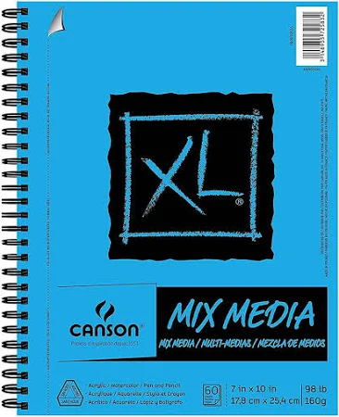  $25 class fee paid online or at fee office  Concerning laptop utilization: 1.Student laptops should not be hard-wired to the network or have print capabilities. 2. Use of discs, flash drives, jump drives, or other USB devices will not be allowed on Madison City computers. 3. Neither the teacher, nor the school is responsible for broken, stolen, or lost laptops. 4. Laptops and other electronic devices will be used at the individual discretion of the teacher.  Requests for accommodations for this course or any school event are welcomed from students and parents.
Example: 18 – WEEK PLAN*
Weeks 1-3 | Unit 1 Color Theory refresh/figure drawing/Process Journal work/Contemporary Artists
Weeks 4-7 | Unit 2 Tell Your Story/Someone Else’s Story/Process Journal/Contemp. Artists/Figure Drawing
Weeks 8-10 | Unit 3 Self-Portrait/Contemp. Artists/Process Journals/Figure Drawing
Weeks 11-15 | Unit 4 Artivism/Process Journals/Contemp. Artists/Figure Drawing
Weeks 16-18 | Unit 5 Project/Process Journals/Contemp. Artists/Figure Drawing
Week 19 | Review for Final

*This is a tentative plan and may change at the discretion of the teacher.

Please sign below to acknowledge that you have received, read, and understood the syllabus.

Student name: ___________________________________

Student signature: __________________________________

Parent/guardian name: ____________________________

Parent/guardian signature: ____________________________

Parent/guardian, please provide two ways for me to contact you (email address, phone numbers):

Parent/guardian Email:

__________________________________________________________________________________________

Parent/Guardian Phone number:

__________________________________________________________________________________________

